How to create an RFC destination ?

Go to SM59 transaction :

[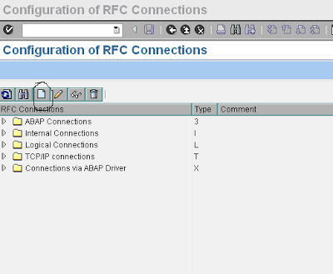](https://4.bp.blogspot.com/-93cJzY4v2IA/TgI6107-5bI/AAAAAAAAAFw/sZT0SeSJNpk/s1600/rfc1.bmp)

Click on create icon in the above screen, which leads to below screen

[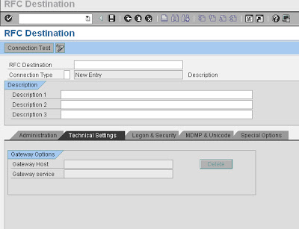](https://4.bp.blogspot.com/-qQJ1tL3t0eQ/TgI63Dl-ECI/AAAAAAAAAF0/odYOiCkbnAo/s1600/rfc2.bmp)

Specify RFC Destination name and description and connection Type in the above screen

[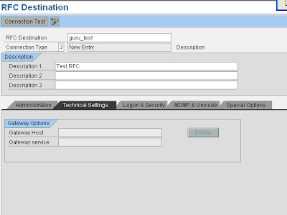](https://2.bp.blogspot.com/-pJBWrMqQjZY/TgI64IPwi4I/AAAAAAAAAF4/w5cHqOZIIQE/s1600/rfc3.bmp)

Please note respective connection type to be selected from dropdown based on the connection required. Usually 3 is for ABAP system. (Pls find screenshot below)

[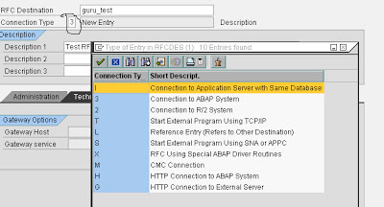](https://3.bp.blogspot.com/-EesM53AMWUM/TgI65ZVu4-I/AAAAAAAAAF8/ep8nZbGZchw/s1600/rfc4.bmp)

In the below screen, please select load balancing radio button based on your system setup (i.e if there is load balancing configured for your system, specify it as yes otherwise no)

Please provide Target host details like hostname or ipaddress and system number as below:

[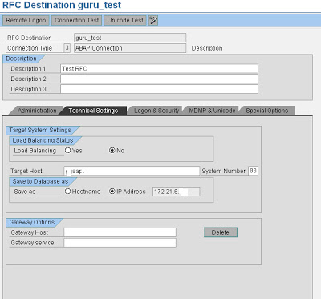](https://4.bp.blogspot.com/-2gaPwJleKI4/TgI679GJZEI/AAAAAAAAAGA/9871Pii0G0Q/s1600/rfc5.bmp)

As shown below, Proceed to Logon & security tab and provide following details :

Select trusted system as no, in case you would like to connect to a system with a user id and password.

 If you don’t want to get authenticated by credentials specify the system as trusted system which won’t prompt to enter user id/pwd credentials in the below screen.

Please provide Language details like EN (for English), Client details, User id and password for the system you would like to create a connection.

[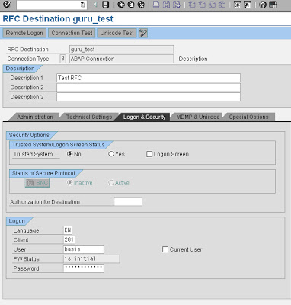](https://3.bp.blogspot.com/-tS2FGH29IEw/TgI69S7krOI/AAAAAAAAAGE/qrOKRCPBkH0/s1600/rfc6.bmp)

Please leave default values in other tabs (i.e MDMP & Unicode, Special options, Administration) and then click on Save to complete the RFC creation.

**How to Test RFC connection ?**

[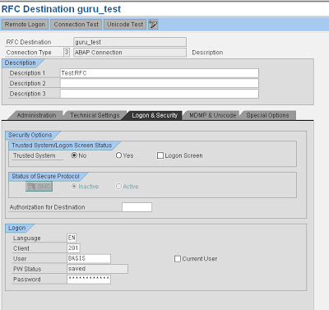](https://3.bp.blogspot.com/-vYV569PO9ZM/TgI6-RnmOWI/AAAAAAAAAGI/glJXUG43AUc/s1600/rfc7.bmp)

If it functioning well it should show output similar to below screen :

[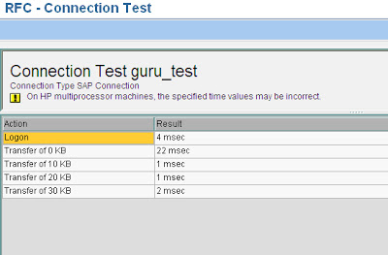](https://2.bp.blogspot.com/-meKy-3XJnFM/TgI6_e_yo6I/AAAAAAAAAGM/vPwlefpw_HM/s1600/rfc8.bmp)

If this is fine, come back to earlier screen and execute Unicode test by clicking the button. Output similar to below screen, should be displayed if connection is OK

[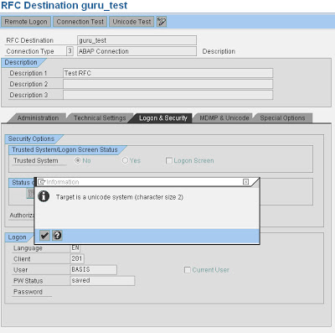](https://1.bp.blogspot.com/-5wAODim4vv8/TgI7AumX1iI/AAAAAAAAAGQ/RS6sLbU-nbI/s1600/rfc9.bmp)

Also you need to perform authorization test to make sure user id / password credentials provided are correct.

Please navigate as below and perform the test :

[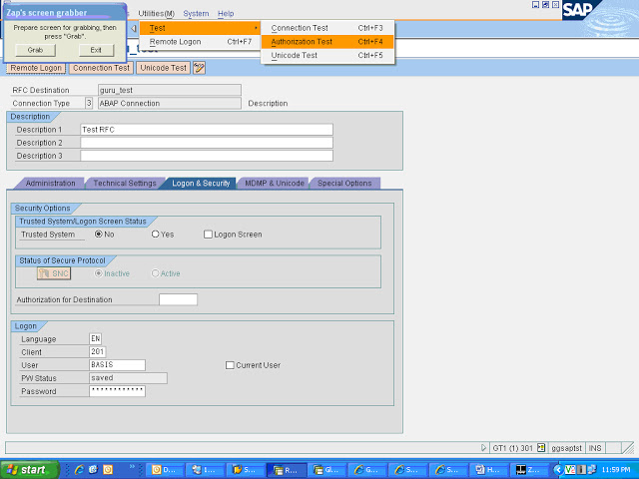](https://3.bp.blogspot.com/-m5AN_x81puc/TgI7DmjPeeI/AAAAAAAAAGU/GDc0eUmEkTI/s1600/rfc10.bmp)

Navigate to Utilities -> Test -> Authorisation test and click  the same to execute.

[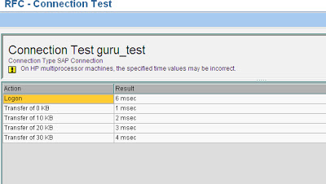](https://3.bp.blogspot.com/-MTxrJt64pkM/TgI7EQXFngI/AAAAAAAAAGY/wHkTBEwi4NM/s1600/rfc11.bmp)

If the RFC configuration is fine, screen shot similar above will appear. Otherwise an error will be displayed based on which you need to troubleshoot to fix the issue.

**How to delete an RFC ?**

Goto SM59 and select the RFC that is to be deleted as shown below :

[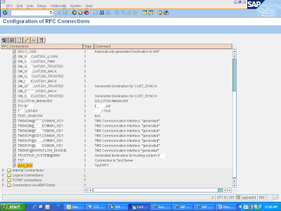](https://1.bp.blogspot.com/-2NVT3lnDHBw/TgI7GWcn12I/AAAAAAAAAGc/8qm33IDAOn8/s1600/rfc12.bmp)

And click on delete icon

[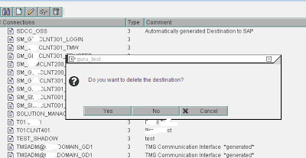](https://3.bp.blogspot.com/-MfU58oTj9D4/TgI7HSkEHqI/AAAAAAAAAGg/KF1OsKKxG54/s1600/rfc13.bmp)

Click yes to confirm deletion, which deletes the RFC.

Click on Connection test tab to check the connection for the RFC